Certificate-Based Authentication Project Report
Comprehensive architecture, workflow, implementation, security behavior, testing evidence, and limitations.
Project: Certificate-Based Authentication Lab and PKI Portal
Prepared: August 3, 2026
Environment: C:\Users\kulka\OneDrive\Desktop\cert-based authentication
Core stack: OpenSSL 3.2.4, Nginx 1.30.1, Python standard library, SQLite

Executive summary
This project demonstrates a complete local certificate-based authentication system. A private PKI issues server and client certificates, Nginx enforces mutual TLS, a Python backend maps verified certificate identity to users, SQLite stores operational data, and CRLs prove revocation behavior.

1. Project Purpose and Scope
The project is a local learning and CV showcase lab for certificate-based authentication. It replaces username/password access for the protected mTLS route with browser-presented client certificates. It also expands the lab into a small PKI operations portal with request approval, certificate issuance, revocation, audit logging, and dashboards.
- Create a private Root CA and Intermediate CA with OpenSSL.
- Generate server certificates, client certificates, and browser-importable PKCS#12 bundles.
- Configure Nginx to require and verify client certificates.
- Forward verified certificate identity details to a Python backend using trusted proxy headers.
- Map certificate Common Name values to users in SQLite.
- Demonstrate expired, revoked, missing, and valid certificate outcomes with saved evidence.

2. Technology Stack
Technology | Role in Project
OpenSSL 3.2.4 | Creates CA hierarchy, keys, CSRs, certificates, PKCS#12 bundles, and CRLs.
Nginx 1.30.1 | Acts as HTTPS server, mTLS verification gateway, reverse proxy, and CRL enforcement point.
Python | Implements the backend portal using http.server, routing, HTML rendering, session handling, subprocess calls, and SQLite access.
SQLite | Stores users, employees, certificate requests, issued certificates, sessions, audit events, and notifications.
Browser | Imports .p12 client certificates and presents them during the TLS handshake.
PowerShell | Runs OpenSSL, backend, Nginx, test commands, and operational commands.

3. Architecture
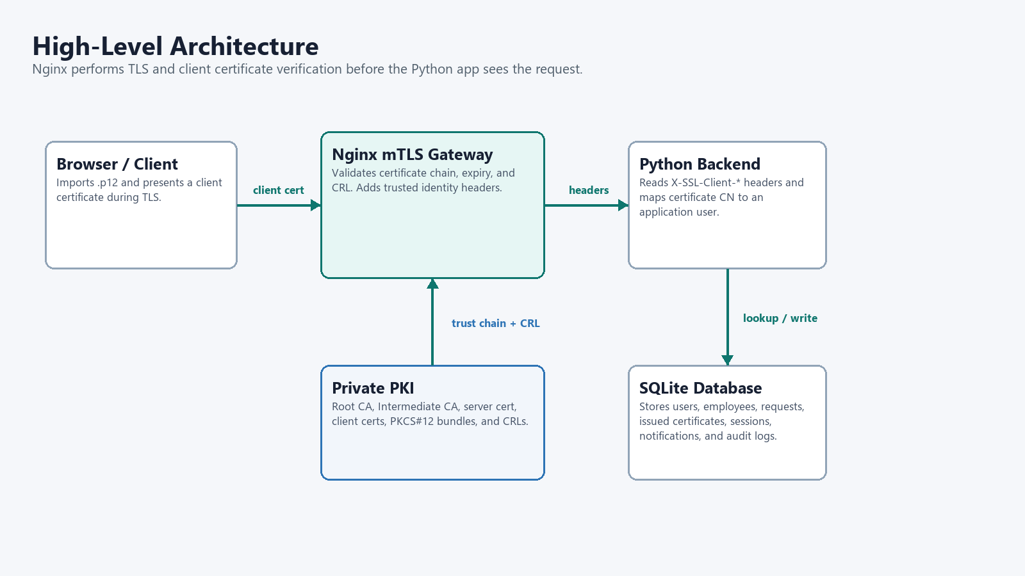
Figure 1. The mTLS gateway owns certificate validation; the backend consumes only trusted headers from the local proxy.
Nginx is the trust boundary. The backend listens on 127.0.0.1:8081 and is intended to be reached only through Nginx. This separation keeps cryptographic certificate validation in the TLS layer while allowing the application layer to focus on user mapping, workflow, and portal behavior.
Layer | Main Files | Responsibility
PKI | pki/certs, pki/private, pki/crl, pki/*-ca-db | Root CA, Intermediate CA, issued certificates, private keys, certificate database, and CRLs.
TLS gateway | nginx/nginx-mtls.conf | Requires client certificates, verifies chain/depth/CRL, and forwards verified identity headers.
Application | app/app.py | Handles login, mTLS result display, certificate request workflow, admin actions, downloads, and audit pages.
Data | app/cert_auth.db | Stores users, portal accounts, sessions, certificate lifecycle records, and evidence-oriented data.
Evidence | evidence/*.txt and logs/*.log | Contains test output proving accept/reject behavior for important certificate states.

4. PKI Design
The PKI uses a Root CA as the trust anchor and an Intermediate CA for issuing operational server and client certificates. This mirrors common production PKI structure: the Root CA remains the top-level trust anchor, while the Intermediate CA signs daily-use certificates and maintains the issuing database.
Certificate / Object | Purpose | Important Project Files
Root CA | Top-level trust anchor. | ca.crt, pki/private/ca.key, pki/root-ca-db/root-ca.cnf
Intermediate CA | Issues server and client certificates. | intermediate.crt, pki/private/intermediate.key, pki/intermediate-ca-db/intermediate-ca.cnf
CA chain | Trust bundle used by Nginx for client verification. | pki/certs/ca-chain.crt
Server certificate | Allows HTTPS on localhost/cert-auth.local. | pki/certs/server-fullchain.crt, pki/private/server.key
Client certificates | Represent client identity for mTLS. | pki/certs/*.crt, pki/private/*.key, *.p12
CRLs | List revoked certificates and allow Nginx to block them. | pki/crl/intermediate.crl, pki/crl/root.crl, pki/crl/ca-chain.crl

Important extension behavior: CA certificates use keyCertSign and cRLSign; the server certificate uses serverAuth and Subject Alternative Names for localhost, 127.0.0.1, ::1, and cert-auth.local; client certificates use clientAuth.

5. mTLS Authentication Workflow
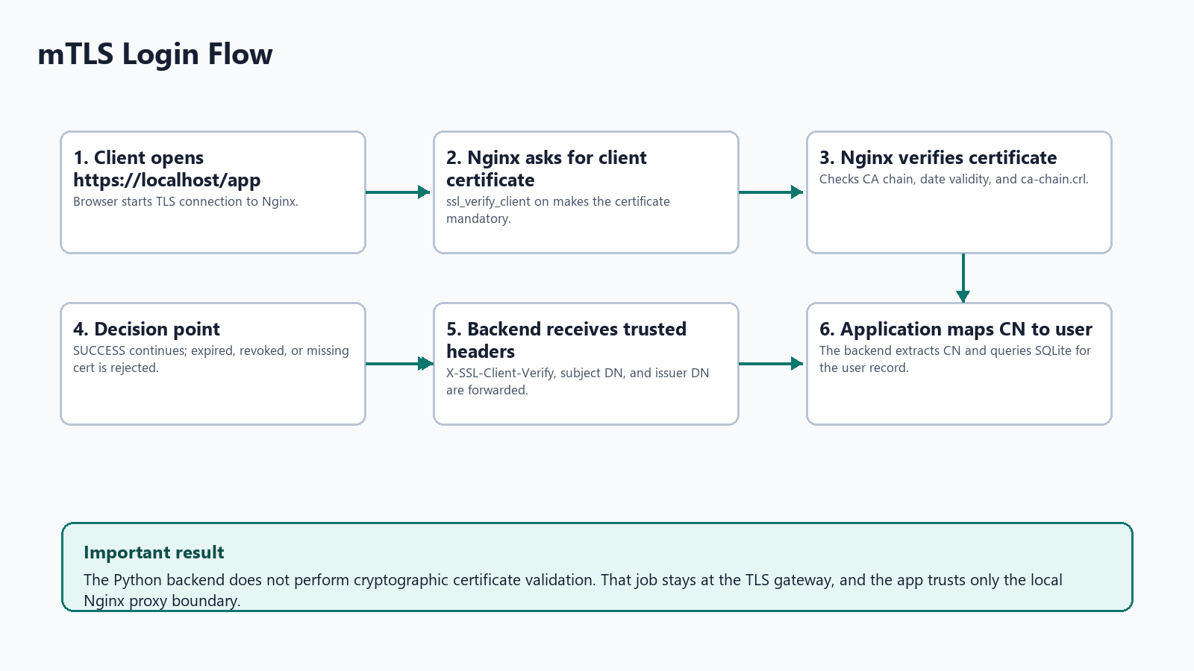
Figure 2. Request handling path from browser certificate selection to backend user mapping.
- The browser opens https://localhost/app.
- Nginx requests a client certificate because ssl_verify_client is enabled.
- The browser presents a client certificate from the user's certificate store.
- Nginx validates the certificate chain against pki/certs/ca-chain.crt.
- Nginx checks validity dates and pki/crl/ca-chain.crl for revocation.
- If verification succeeds, Nginx forwards the request to 127.0.0.1:8081 with X-SSL-Client-* headers.
- The backend extracts the certificate Common Name and maps it to a user record.
ssl_client_certificate "C:/Users/kulka/OneDrive/Desktop/cert-based authentication/pki/certs/ca-chain.crt";
ssl_crl "C:/Users/kulka/OneDrive/Desktop/cert-based authentication/pki/crl/ca-chain.crl";
ssl_verify_client on;
ssl_verify_depth 2;
proxy_set_header X-SSL-Client-Verify $ssl_client_verify;
proxy_set_header X-SSL-Client-DN $ssl_client_s_dn;
proxy_set_header X-SSL-Client-Issuer-DN $ssl_client_i_dn;

6. Backend and Portal Functionality
The backend is implemented in app/app.py using Python's standard-library HTTP server stack. It includes HTML rendering, form handling, session cookies, password hashing, certificate request management, OpenSSL command execution, revocation automation, and audit/notification storage.
Route / Feature | Purpose
/app | Shows the mTLS login result and certificate identity mapping.
/login and /logout | Role-account login for portal workflows.
/app/portal | Employee certificate request and download area.
/app/manager | Manager approval and rejection queue.
/app/admin | Admin dashboard with signing queue, metrics, alerts, and recent activity.
/app/admin/users | Employee/user management.
/app/admin/certificates | Certificate inventory and revocation entry point.
/app/certificate and /app/download | Certificate details and .p12 download.
/app/audit | Compliance-oriented audit log view.

Database Table | Stores
users | CN-to-user mapping for mTLS login.
employees | Portal accounts, manager relationship, department, role, and password hash.
sessions | Authenticated role-login sessions.
certificate_requests | Employee requests and manager/admin decisions.
certificates | Issued certificate records, status, file paths, serials, expiry, and revocation metadata.
audit_log | Workflow and security-relevant action history.
notifications | User-facing workflow notifications.

7. Certificate Lifecycle Workflow
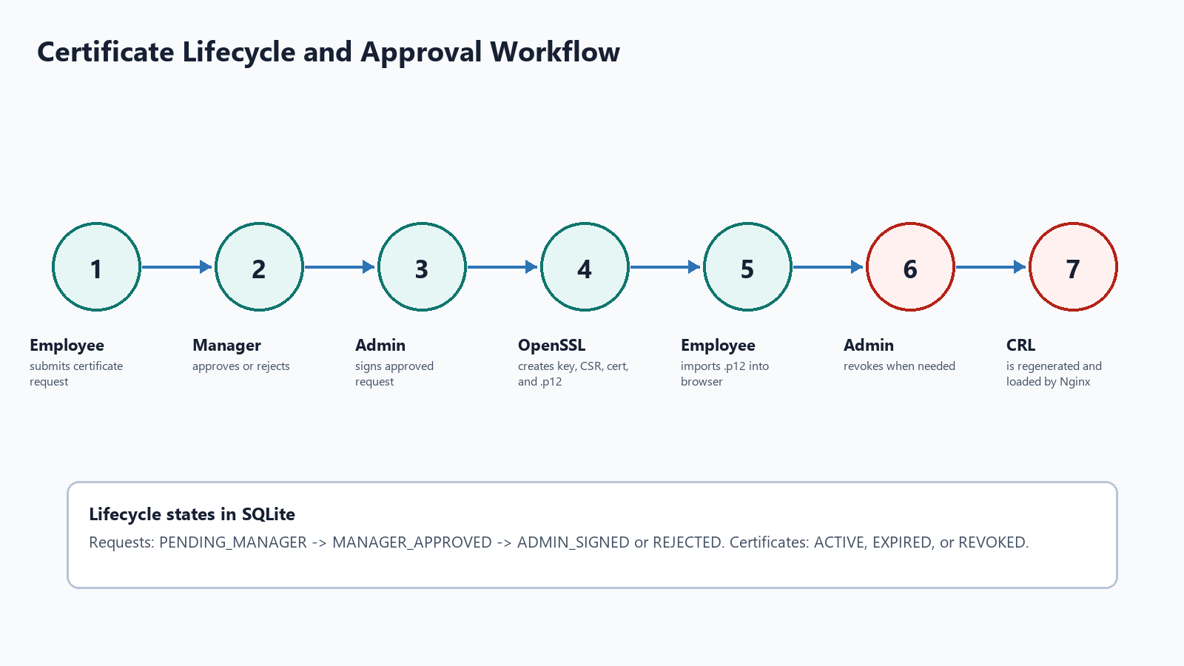
Figure 3. Portal-driven certificate request, approval, signing, import, and revocation workflow.
The level-up portal turns the authentication lab into a lifecycle demonstration. Employees can request certificates; managers approve; administrators sign using OpenSSL; issued PKCS#12 bundles are recorded and downloadable; administrators can revoke certificates, regenerate CRLs, reload Nginx, and leave an audit trail.

8. Revocation Model
Revocation is implemented with Certificate Revocation Lists. Revoking a certificate does not edit the certificate itself. Instead, OpenSSL records its serial number in the Intermediate CA database and emits an updated CRL. Nginx loads the combined CRL chain and blocks certificates whose serial appears in that CRL.
& "C:\Program Files\Git\usr\bin\openssl.exe" ca -batch `
-config pki\intermediate-ca-db\intermediate-ca.cnf `
-revoke pki\certs\revoked-client.crt
& "C:\Program Files\Git\usr\bin\openssl.exe" ca -batch `
-config pki\intermediate-ca-db\intermediate-ca.cnf `
-gencrl -crlexts crl_ext `
-out pki\crl\intermediate.crl

9. Test Evidence
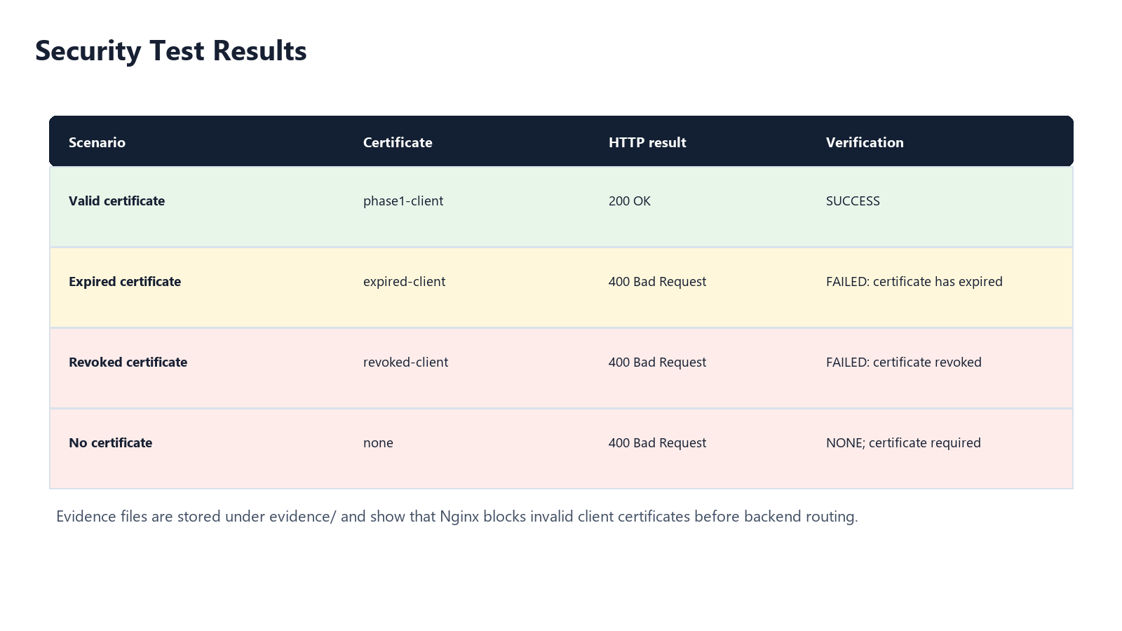
Figure 4. Saved evidence proves each expected mTLS security outcome.
Scenario | Certificate | Expected and Actual Result | Evidence File
Valid certificate | phase1-client | Accepted: HTTP/1.1 200 OK and X-SSL-Client-Verify: SUCCESS. | evidence/01-valid-client.txt
Expired certificate | expired-client | Rejected: HTTP/1.1 400 Bad Request and FAILED:certificate has expired. | evidence/02-expired-client.txt
Revoked certificate | revoked-client | Rejected: HTTP/1.1 400 Bad Request and FAILED:certificate revoked. | evidence/03-revoked-client.txt
No certificate | none | Rejected: HTTP/1.1 400 Bad Request and X-SSL-Client-Verify: NONE. | evidence/04-no-client-cert.txt

10. Security Concepts Demonstrated
- Public Key Infrastructure: root trust, intermediate issuing, certificate chains, serial numbers, validity periods, and extensions.
- Mutual TLS: both server and client identity are checked during the TLS handshake.
- Certificate-based identity: the application maps the verified certificate Common Name to a local user.
- Trust boundary design: only Nginx validates certificates; the backend trusts headers from the local proxy boundary.
- Revocation: CRLs let the system disable a certificate before its expiration date.
- Auditability: operational actions such as requests, approvals, signing, and revocation are logged.

11. Limitations and Production Hardening
Current Lab Limitation | Production Hardening Idea
Local files hold CA private keys. | Use secure key storage, offline Root CA procedures, restricted permissions, or an HSM.
CN is used as a simple identity key. | Use SAN email/URI or a stable certificate subject mapping policy.
CRL is local and manually regenerated/reloaded in the lab. | Publish CRLs or use OCSP/OCSP stapling where appropriate.
Backend trusts proxy headers by deployment design. | Block direct backend exposure and strip inbound spoofed identity headers at the edge.
SQLite is local and single-node. | Use a managed database and migration framework for multi-user production use.
Demo passwords and local bundle passwords are documented. | Use secret management, enrollment controls, and per-user delivery channels.

12. Interview and CV Summary
CV-ready summary
Built a certificate-based authentication lab using OpenSSL, Nginx mTLS, Python, and SQLite. Implemented a private CA chain, browser-importable client certificates, Nginx client certificate enforcement, backend CN-to-user mapping, CRL-based revocation, a PKI request/approval/signing portal, audit logging, and evidence for valid, expired, revoked, and missing certificate scenarios.

13. Project Folder Map
cert-based authentication/
app/ Python backend and SQLite database
evidence/ Saved mTLS test outputs
logs/ Nginx mTLS access and error logs
nginx/ mTLS gateway configuration
pki/ CA databases, certs, keys, CSRs, CRLs, extension configs
tools/nginx-1.30.1/ Local Nginx runtime
www/ Static landing page
*.p12 Browser-importable client certificate bundles

